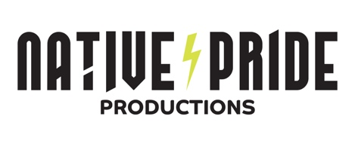
FOR IMMEDIATE RELEASE

Native Pride Productions Invited by United States Embassy Australia
to Join in Cultural Exchange Tour and Performances

Jacksonville, FL, October 8, 2024 - The Native Pride Productions team receives a special invitation to tour Australia October 13-27, 2024 with performances in Perth, Sydney and Melbourne. The tour, supported by the U.S. Embassy and Consulates in Australia, aims to foster cultural exchange and highlight the rich heritage of Indigenous peoples of the United States and Australia.
Audiences will experience the dynamic traditions, storytelling, and artistry that characterize Native American culture, through highly entertaining and educational events. Native Pride Productions’ powerful performances will inspire all ages through a mix of modern and traditional Native American dance styles with brightly-colored regalia with ribbons, feathers, and furs.
Key events will include “First Nations Fusion” with Noongar performers at Yagan Square in Perth on October 13, “Dance Rites” the national First Nations dance competition at the Sydney Opera House and South by Southwest (SXSW) Sydney on October 19, and a public performance at Federation Square in Melbourne on October 27.
“We are thrilled to be welcomed in Australia to share our culture through the universal language of dance,” said Larry Yazzie, Founder and Artistic Director, Native Pride Productions. “This cultural exchange represents a wonderful opportunity to grow connections between our peoples and celebrate our shared stories,” added Yazzie.
U.S. Embassy Counsellor for Public Affairs Jared Caplan said, “The visit will celebrate and showcase the richness of Native American culture and highlight the diversity of the United States.
“We are pleased to invite the team from Native Pride Productions to Australia to share their art of dance, unique stories and traditions to offer Australians a unique opportunity to experience and engage with Native American heritage,” Mr. Caplan said.

About Native Pride Productions
Founded in 2003 and based in Jacksonville, Florida, Founder Larry Yazzie’s mission is to preserve Native American culture through dance, music, and storytelling. Native Pride Productions’ goal is to share cultural traditions through artist-in-residency workshops, performances, lectures, classroom instruction and theatrical performances enhancing access to diverse, multicultural artists for people of all ages and backgrounds. The Native Pride Productions team and our diverse group of dancers are available to share their rich culture through performances and educational events worldwide.

For media inquiries contact:
Pauline Gerry, pgerry@azmarkinc.com I 904.728.4722
nativeprideproductions.com
Event booking inquiries: nativeprideproductions.com/booking

###

